**PROJECT INTRODUCTION: THE WEBSITE PLAN: RAFTING COMPANY**

**GRAPHICAL IDENTITY**

**Author:** Francisco de Paula Barros

**Activit:** W03 Project Graphical Identity

1. The image file you selected for the site logo.

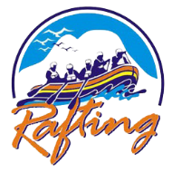

1. Write out the color codes for the following colors:
   * **primary-color:** # 790ad4
   * **secondary-color:** # C200FB
   * **accent1-color:** # EC0868
   * **accent2-color:** # EC7D10

and the names of the fonts you chose for the following labels:

* + **heading-font:**

font-family: "Roboto", sans-serif;

font-weight: 400;

font-style: normal;

* + **text-font:** Roboto

font-family: "Roboto", sans-serif;

font-weight: 100;

font-style: normal;

1. Provide the URL of your color palette from coolors.co.:

https://coolors.co/3A0334-440437-EC0868-ec7d10